Name : Kasak Patel
Roll No : 05
Sec-Batch : B-B1
ML Lab 3
Aim :
To implement Find-S and Candidate Elimination Algorithms on the Enjoy Sports dataset and compare the generated hypotheses.

1. Objective
- To understand the concept of concept learning in machine learning.
- To implement the Find-S algorithm using a given training dataset.
- To determine the most specific hypothesis that is consistent with positive training examples.
- To understand the concept of specific and general boundaries.
- To implement the Candidate Elimination algorithm for maintaining the version space.
- To observe how the hypothesis changes as different training examples are processed.
- To determine the final specific and general boundaries from the given dataset.

2. Theory
Concept learning is a fundamental machine learning approach in which a system learns a general concept from a set of labelled training examples. Each example contains several attributes and a target class that indicates whether the example belongs to the concept or not. In this experiment, the concept is represented by the EnjoySport target attribute, which contains Yes and No values. The dataset contains attributes such as Sky, AirTemp, Humidity, Wind, Water, and Forecast.
2.1 Find-S Algorithm
The Find-S algorithm is a concept-learning method that finds the most specific hypothesis consistent with all positive training examples. It starts with an initially empty hypothesis and processes the training examples one by one.
When a positive example is encountered, its attribute values are used to initialize or update the hypothesis. If a later positive example has a different value for an attribute, that attribute is replaced with ?. The symbol ? means that any value of that attribute is acceptable.
In this experiment, the Find-S algorithm begins with an initial hypothesis of None. After processing the positive examples, the final hypothesis obtained from the dataset is:
['Sunny', 'Warm', '?', '?', '?', '?']
This means that the learned concept mainly requires Sunny weather and Warm air temperature, while the remaining attributes can have any value.
2.2 Candidate Elimination Algorithm
The Candidate Elimination algorithm is another concept-learning technique that maintains the set of hypotheses consistent with the training examples. It represents the learned concept using two boundaries: the Specific Boundary (S) and the General Boundary (G).
The Specific Boundary contains the most specific hypotheses that are consistent with the observed examples. The General Boundary contains the most general hypotheses that remain consistent with the examples.
Initially, the Specific Boundary is set to the first training example, while the General Boundary contains a completely general hypothesis represented by ? for every attribute. As each training example is processed, both boundaries are updated according to whether the example is positive or negative.
In this experiment, the final Specific Boundary obtained is:
['Sunny', 'Warm', '?', '?', '?', '?']
The algorithm also produces a Final General Boundary containing the hypotheses that remain consistent with the training data.
2.3 Hypothesis Representation
A hypothesis represents a possible description of the target concept. Specific attribute values indicate that a particular value is required, whereas ? indicates that any value is acceptable.
For example:
['Sunny', 'Warm', '?', '?', '?', '?']
means that the concept accepts examples where the Sky is Sunny and AirTemp is Warm, while the other four attributes are unrestricted.

3. Materials and Software Used
- Python 3.x
- Google Colab / Jupyter Notebook
- Pandas library
- NumPy library
- enjoy.csv dataset
- Internet browser for accessing Google Colab
- GitHub for storing the program code and notebook
The PDF shows that the dataset is uploaded and loaded as enjoy.csv in Google Colab, followed by the use of Pandas and NumPy.

4. Procedure
- Open Google Colab and create a new notebook.
- Import the required Python libraries such as Pandas and NumPy.
- Upload the enjoy.csv dataset into the Colab environment.
- Load the dataset using pd.read_csv().
- Display the first few records using df.head().
- Separate the input attributes from the target EnjoySport column.
- Implement the Find-S algorithm using a Python function.
- Initialize the hypothesis as None.
- Process the training examples one by one.
- Consider only the positive examples whose target value is Yes.
- Compare the attributes of each positive example with the current hypothesis.
- Replace differing attribute values with ?.
- Display the hypothesis after each positive training example.
- Display the final Find-S hypothesis.
- Implement the Candidate Elimination algorithm.
- Initialize the Specific Boundary using the first training example.
- Initialize the General Boundary using ? for every attribute.
- Process all training examples and update the Specific and General boundaries.
- Display the Specific and General boundaries after each example.
- Display the final Specific Boundary and Final General Boundary.
- Analyze the final hypotheses obtained from both algorithms.

5. GitHub Repository
GitHub Repository URL: https://github.com/GauriRaut58/Gauri/blob/main/LAB_3_ML_C_52_GAURI%20RAUT.ipynb
The program code and Google Colab/Jupyter Notebook for this practical can be maintained in a GitHub repository. GitHub provides a convenient platform for storing and sharing the implementation of the Find-S and Candidate Elimination algorithms.
The repository can contain:
- enjoy.csv
- ML Lab-3 Jupyter/Colab notebook
- Find-S algorithm code
- Candidate Elimination algorithm code
- Program outputs
- Documentation related to the experiment
6. Program Code and Output Description

Import Libraries and Upload Dataset
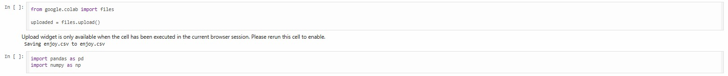

Load Dataset
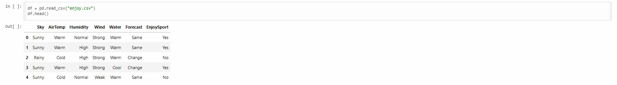

Separate Features and Target
➔ Output Description –
The above three code sections prepare the dataset for concept learning. The enjoy.csv file is uploaded and loaded successfully into a Pandas DataFrame. The first few records display the attributes and the target EnjoySport. The input attributes are stored in X, while the target values are stored in y.

Define Find-S Function
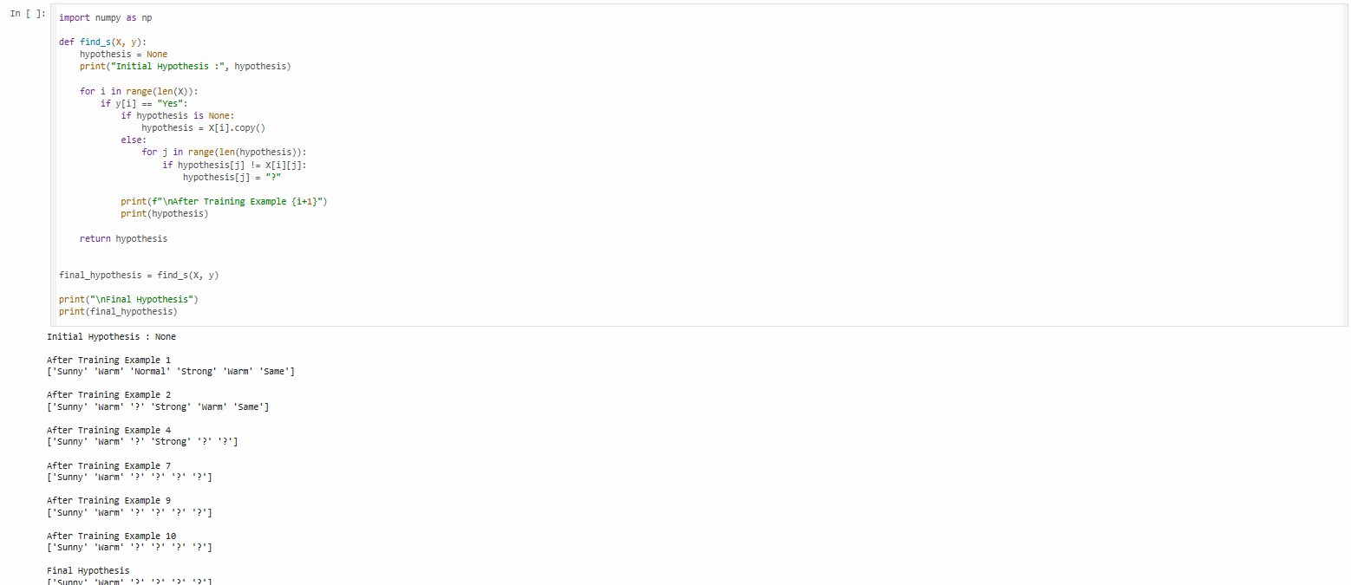
➔ Output Description –
The above three code sections implement the Find-S algorithm. The algorithm starts with an empty hypothesis and considers only positive training examples. Whenever an attribute differs between positive examples, its value is replaced with ?. After processing the positive examples, the final hypothesis obtained is ['Sunny', 'Warm', '?', '?', '?', '?'].

Candidate Elimination Initialization
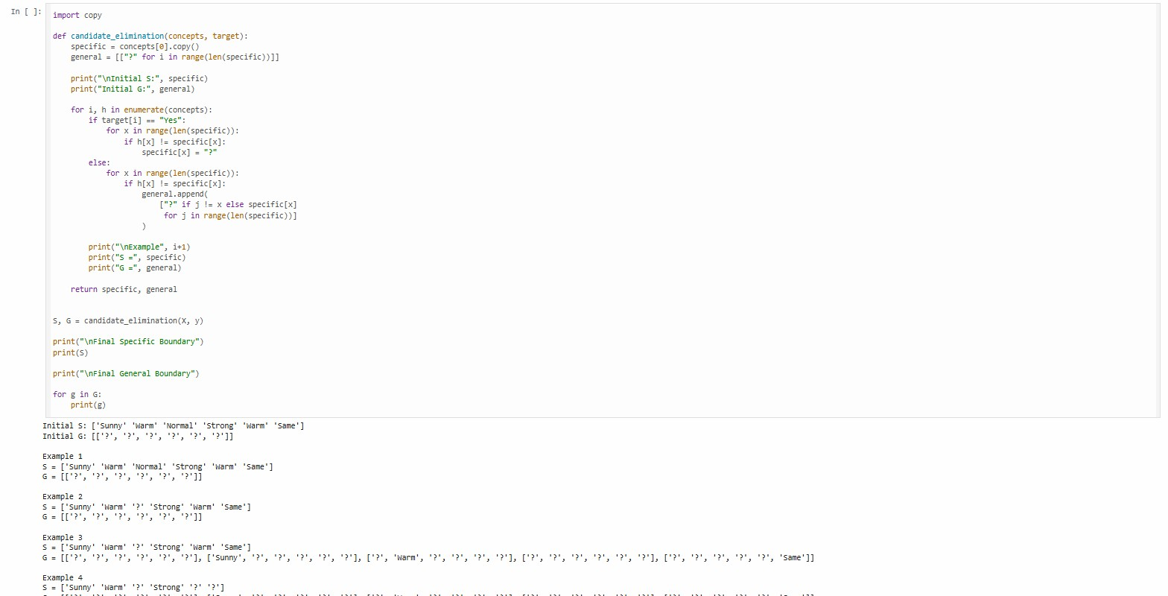
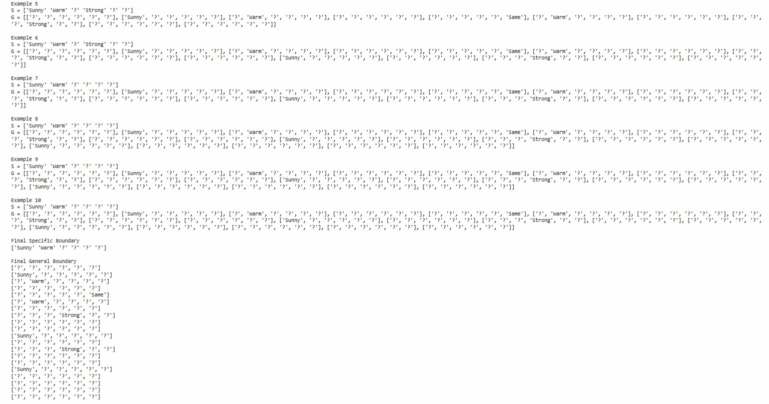
➔ Output Description –
The above code implements the Candidate Elimination algorithm using the given training dataset. It initializes the Specific Boundary with the first training example and the General Boundary with completely general hypotheses. The boundaries are updated as each positive and negative training example is processed. The program displays the Specific and General Boundaries after each example and finally displays the Final Specific Boundary and Final General Boundary.

7. Result
The Find-S and Candidate Elimination algorithms were successfully implemented using the enjoy.csv dataset. The Find-S algorithm produced the final hypothesis:
['Sunny', 'Warm', '?', '?', '?', '?']
The Candidate Elimination algorithm also produced the same final Specific Boundary, while maintaining the General Boundary of consistent hypotheses. The experiment demonstrated how concept-learning algorithms update hypotheses using positive and negative training examples.

8. Viva Questions and Answers
Q1. What is concept learning?
Answer:
Concept learning is the process of learning a general rule or concept from a collection of labelled training examples.
Q2. What is the Find-S algorithm?
Answer:
Find-S is a concept-learning algorithm that finds the most specific hypothesis consistent with all positive training examples.
Q3. What does ? represent in a hypothesis?
Answer:
The symbol ? represents a general condition, meaning that any value of that particular attribute is acceptable.
Q4. What are the Specific and General Boundaries in Candidate Elimination?
Answer:
The Specific Boundary (S) represents the most specific hypotheses consistent with the training data, while the General Boundary (G) represents the most general consistent hypotheses.
Q5. What is the final hypothesis obtained using Find-S in this experiment?
Answer:
The final hypothesis is:
['Sunny', 'Warm', '?', '?', '?', '?']
This means that Sky must be Sunny and AirTemp must be Warm, while the other attributes can take any value.

9. Conclusion
The experiment successfully demonstrated the implementation of concept learning algorithms using the given enjoy.csv dataset. The Find-S algorithm was used to obtain the most specific hypothesis from the positive examples, while the Candidate Elimination algorithm maintained the Specific and General boundaries during training. The final Specific Boundary obtained was ['Sunny', 'Warm', '?', '?', '?', '?']. Thus, the practical provided an understanding of how hypotheses are formed, generalized, and updated during concept learning.

